Supporting information

“Radical substitution with azide: TMSN₃/PhI(OAc)₂ as a substitute of IN₃.” C. M. Pedersen, L. G. Marinescu, M. Bols, (submitted).

Index:
Tabel S1. Ratio of products in the substitution of 21 with PhI(OAc)₂/TMSN₃. S1
Tabel S2. Ratio of products in the substitution of 21 with IN₃. S2
Figure S1. Hammett of the log(ratio) versus σ for substitution of 21 with PhI(OAc)₂/TMSN₃. S2
Figure S2. Hammett of the log(ratio) versus σ for substitution of 21 with IN₃ S2
NMR assignments and other spectral data for known compounds S3-4
¹H NMR of compounds 2-44 S5-S24

 | Ratio | log (ratio)
p-OMe | 2.5 | 0.40
m-OMe | 0.82 | -0.09
p-NO₂ | 0.45 | -0.35
m-NO₂ | 0.52 | -0.29
p-Br | 0.78 | -0.11
m-Br | 0.63 | -0.20
m-Cl | 0.57 | -0.24
H | 1 | 0

Table S1. Ratio of products in the substitution of 21 with PhI(OAc)₂/TMSN₃.

 | Ratio | log (ratio)
p-OMe | 2 | 0.30
m-MeO | 0.91 | -0.04
p-NO₂ | 0.51 | -0.29
p-Br | 0.85 | -0.07
m-Br | 0.67 | -0.17
m-Cl | 0.71 | -0.15
H | 1 | 0

Table S2. Ratio of products in the substitution of 21 with IN₃.

Figure S1. Hammett of the log(ratio) versus σ for substitution of 21 with PhI(OAc)₂/TMSN₃.

Figure S2. Hammett of the log(ratio) versus σ for substitution of 21 with IN₃.
NMR assignments and other spectral data for known compounds:

2: ¹H NMR: δ 7.22 - 7.38 (m, 5H), 5.24 (s, 1H), 3.43 (s, 3H).

4: ¹H NMR (400 MHz, CDCl₃): δ= 7.48-7.38 (m, 10H, Ph); 5.66 (s, 1H, PhCH); 5.58 (s, 1H, PhCH’); 5.49 (d, 1H, J_{H1,H2}=3.6 Hz, H1); 5.11 (d, 1H, J_{H1’,H2’}=3.6 Hz, H1’); 5.03 (dd, 1H, J_{H2,H1}=3.6 Hz, J_{H2,H3}=8.4 Hz, H2); 4.94 (dd, 1H, J_{H1’,H2’}=3.6 Hz, J_{H2’,H3’}=8 Hz, H2’); 4.47-4.22 (m, 5H, H3, H3’, H4, H4’, H5b’); 4.12 (d, 1H, J_{gem}=13.6 Hz, H5a) 4.01 (d, 1H, J=13.2 Hz, H5a’); 3.85 (dd, 1H, J_{H5b,H4}=3.2 Hz, J_{gem}=13.6 Hz, H5b); 2.17 (s, 3H, COMe); 2.05 (s, 3H, COMe); 1.57 (s, 3H, Me); 1.54 (s, 3H, Me’); 1.38 (s, 3H, Me); 1.36 (s, 3H, Me’). ¹³C NMR (100 MHz, CDCl₃): δ= 169.6 (COMe); 169.3 (Ac); 135.2, 135.2, 128.6, 128.5, 127.8, 127.7, 125.2, 124.9 (Ph); 108.6 (2xCMe₂); 94.6 (C1); 92.6 (C1); 90.2 (PhCH₂); 86.7 (PhCH₂); 72.2, 72.1, 71.6, 71.6, 70.8, 70.5, 58.8, 58.6 (2x(C2, C3, C4, C5)); 26.9 (Me); 26.9 (Me); 25.3 (Me); 25.2 (Me); 19.9 (COMe); 19.8 (COMe). IR (NaCl) / cm⁻¹: ν = 3065, 3033 (Ar C-H sp²), 2987, 2936, 2878 (C-H sp³), 2111(vs) (N₃), 1740(vs) (C=O). MS(ES): calc. for (M + Na)= 386.1328, found 386.1322.

6: ¹H NMR (CDCl₃, 400 MHz): δ 7.45-7.36 (5H, m, Ar-H), 5.39 (1H, s, O-CHN₃-Ar), 4.19 (2H, br. s, H-1,5), 4.13 (1H, t, H-3, J = 4,4 Hz), 2.22-1.78 (8H, m, 2H-2,4,6,7), 1.46 (9H, s, (CH₃)₃, Boc). ¹³C NMR (CDCl₃, 100 MHz): δ 153.6 (C=O, Boc), 137.5 (C(Ar)), 129.3; 129.2; 128.9 (CH(Ar)), 91.5 (O-CHN₃-Ar), 79.4 (C(CH₃)₃, Boc), 72.4 (C₃), 53.1/52.3 (C_{1,5}), 37.2/36.4 (C_{2,4}), 35.3/34.4 (C_{6,7}), 28.7/28.0 ((CH₃)₃C, Boc). IR (NaCl) / cm⁻¹: ν = 3444, 2978 (C-H sp³), 2103 (N₃), 1694, 1652, 1548 cm⁻¹.

8: ¹H-NMR (CDCl₃): δ = 7.34-7.51 (m, 10 H, Ar), 5.529 (s, 1H, Ar-CH-N₃), 4.93 (d, 1 H_{a}, J = 11.6, Ar-CH₂), 4.73 (d, 1 H_{b}, J = 11.6, Ar-CH₂). ¹³C-NMR (CDCl₃): δ = 136.9 (1 C, Ar C₁), 129.3-126.3 (11 C, Ar), 91.5 ( Ar-CH-N₃), 70.4 (Ar-CH₂). IR (KBr) / cm⁻¹: ν  = 3033/3065 (C-H sp²), 2874 (C-H sp³), 2105 (-N₃), 1495,1587 (Ar), MS(ES): calc. for (M + Na)= 262.0956, found 262.0950

24b: ¹H-NMR (CDCl₃): δ = 7.35-7.27 (m, 5H, Ar), 6.36 (dt, J=1.1, J=12.7, 0.67 H, H_{4E}), 5.95 (dt, J=1.5, J=6.3, 0.33 H, H_{4Z}), 4.75 (dt, J=7.4, J=12.7, 0.67 H, H_{3E}), 4.53 (s, 2H, PhCH₂-), 3.43 (dt, J=6.4, J=7.3, 0.33 H, H_{3Z}), 3.59 (s, 1H, Me_{Z}), 3.51 (s, 2H, Me_{E}), 3.48 (t, J=6.9, 0.66H, H_{1Z}), 3.46 (t, J=6.9, 1.44H, H_{1E}), 2.40 (dk, J=1.4, J=6.9, 0.66 H, H_{2Z}), 2.25 (dk, J=1.2, J=7.0, 1.44 H, H_{2E}). ¹³C-NMR (CDCl₃): δ = 148.6 (C_{4E}), 147.6 (C_{4Z}), 138.7(Ar-1_{Z}), 138.8 (Ar-1_{E}), 128.5-127.6 (10 Ar), 102.9 (C_{3Z}), 99.2 (C_{3z}), 73.1 (PhCH_{2E}), 73.0 (PhCH_{2Z}), 71.3 (C_{1E}), 70.2 (C_{1Z}), 59.8 (Me_{Z}), 59.1 (Me_{E}), 28.6 (C_{2E}), 24.8 (C_{2Z}).

30: ¹H NMR (400 MHz, CDCl₃): δ 5.28 (bs, 1H), 3.2 (q, 2H, J = 8.0 Hz), 1.52-1.44 (m, 2H), 1.29-1.21 (m, 8H), 0.84 (t, 3H, J = 7.2 Hz). ¹³C-NMR (100 MHz, CDCl₃): δ 156.6 (C=O), 41.3 (C₁), 31.8 (C₅), 29.6 (C₂), 29.05 (C₄), 26.8 (C₃), 22.7 (C₆), 14.1 (C₇). IR (KBr) / cm⁻¹: 1702 (C=O), 2139.7 (N₃), 2858/2929 (C-H sp³), 3331.8 (NH).

32: mp = 85.5 ºC. ¹H NMR (400 MHz, CDCl₃): δ = 7.25-7.10 (m, 5H), 4.99 (bs, 1H), 3.42 (q, 2H, J = 6.7 Hz), 2.75 (t, 2H). ¹³C-NMR (100 MHz, CDCl₃): δ 155.4 (C=O), 137.1 (Ar C₁), 127.6 (Ar C_{3,4,5}), 125.6 (Ar C_{2,6}), 41.1 (CH₂-NH), 34.5 (CH₂). IR (KBr) / cm⁻¹: 1543 (N-C=O), 1671.8 (strong C=O), 2141.9 (N₃), 2930.2 (C-H sp³), 3029 (C-H sp²) 3280.3 (NH).
MS(ES): calc. for (M + Na)= 213.0752, found 213.0758.

34: ¹H NMR (400 MHz, CDCl₃): δ = 7.4 (m, 3H), 7.1 (m, 2H), 7 (bs, 1H). ¹³C-NMR (100 MHz, CDCl₃): δ 154.5 (C=O), 137.1 (Ar C₁), 129.3 (Ar C_{3,5}), 124.9 (Ar C₄), 119.7 (Ar C_{2,6}). IR (KBr) / cm⁻¹: 1554 (N-C=O), 1688.6 (strong C=O), 2147.4 (N₃), 3325.6 (NH). MS(ES): calc. for (M + Na)= 185.0439, found 185.0443.

36: mp = 130.7 ºC. ¹H NMR (400 MHz, CDCl₃): δ = 7.2 (d, 2H, J = 8.0 Hz), 7 (d, 2H, J = 8.0 Hz), 6.7 (bs, 1H), 2.2 (s,3H). ¹³C NMR (100 MHz, CDCl₃): δ = 154.2 (C=O), 134.6 (Ar C₁), 129.8 (Ar C_{3,4,5}), 119.6 (Ar C_{2,6}), 21.03 (CH₃). IR (KBr) / cm⁻¹: 3276 (NH), 2143, (medium, N₃ ), 1682 (strong, C=O), 1538 (N-C=O). MS(ES): calc. for (M + Na)= 199.0595, found 199.0594

40: ¹H-NMR (CDCl₃): δ = 7.33 (d, J=6.9, 2H, Ar-3/Ar-3’), 7.00 (bs, 1H, NH), 6.85 (d, J=6.9, 2H, Ar-2/Ar-2’), 3.78 (s, 3H, OMe). ¹³C-NMR (CDCl₃): δ = 156.9 (C=O), 154.4 (Ar-1), 130.2 (Ar-4), 121.5 (Ar-3/Ar-3’),114.5 (Ar-2/Ar-2’), 55.7 (OCH₃). IR (NaCl) / cm⁻¹: ν = 3292(s) (NH), 3204, 3141, 3081 (Ar- C-H sp²), 2996, 2955, 2835 (C-H sp³), 2147(vs) (N₃), 1702(vs), 1674(vs) (C=O), 1610, 1557, 1511 (Ar C-H). MS(ES): calc. for (M + Na)= 215.0545, found 215.0549

44: ¹H-NMR (CDCl₃): δ = 8.01 (m, 2H, Ar), 7.52(m, 1H, Ar), 7.40 (m, 2H, Ar), 4.34 (t, J=6.3, 2H, CH₂-O-), 3.54 (t, J=7.0, 2H, -CH₂N). ¹³C-NMR (50 MHz) (CDCl₃): δ = 166.4 (C=O), 133.4, 129.9, 128.6 (Ar), 63.8 (CH₂O), 50.1 (CH₂N). IR (NaCl) / cm⁻¹: ν = 3064 (Ar C-H sp³), 2956 (C-H sp³), 2103(vs) (N₃), 1723(vs) (C=O), 1602, 1584, 1492 (Ar). MS(ES): calc. for (M + Na)= 214.0593, found 214.0596

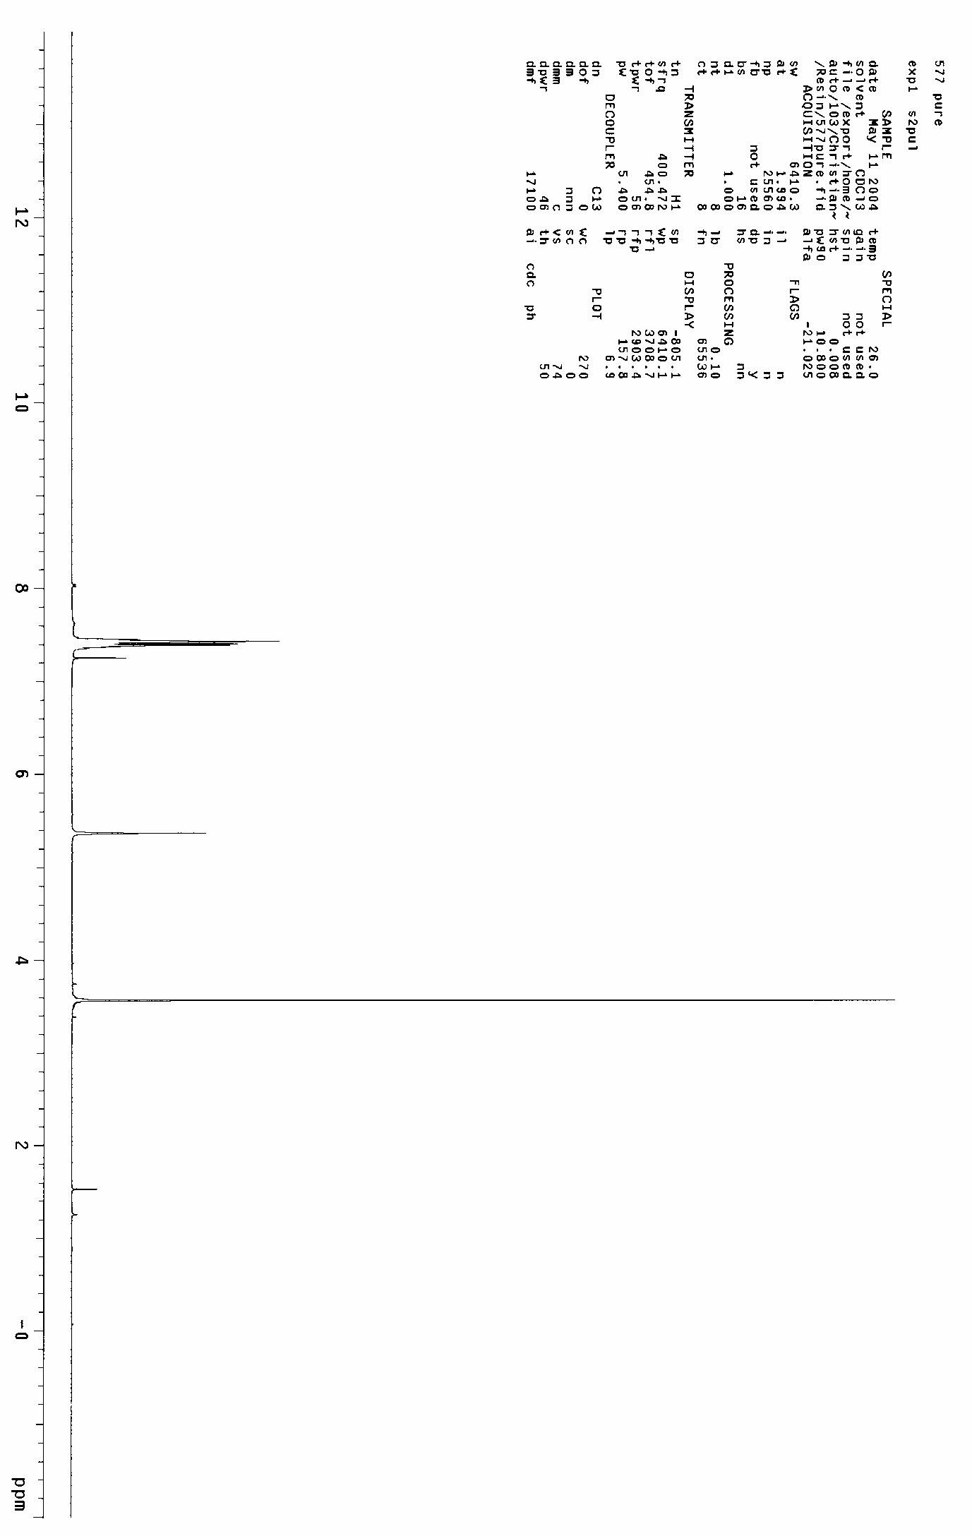
2

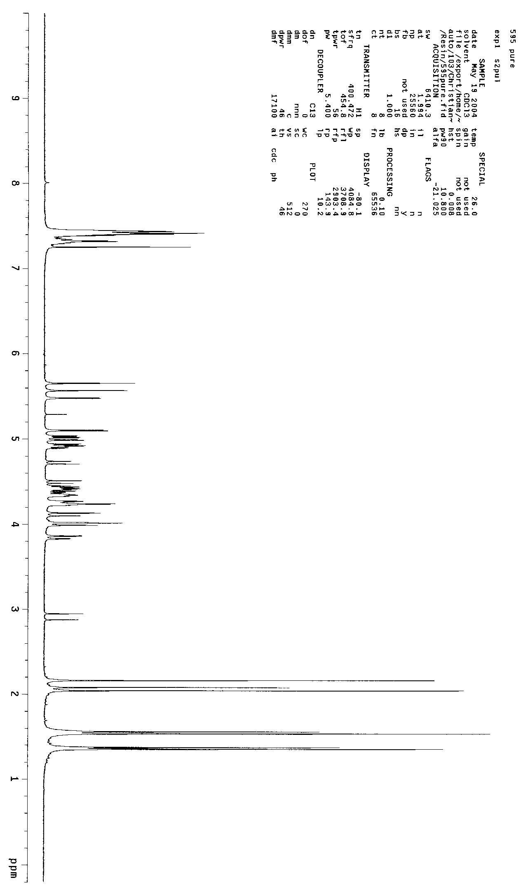
4

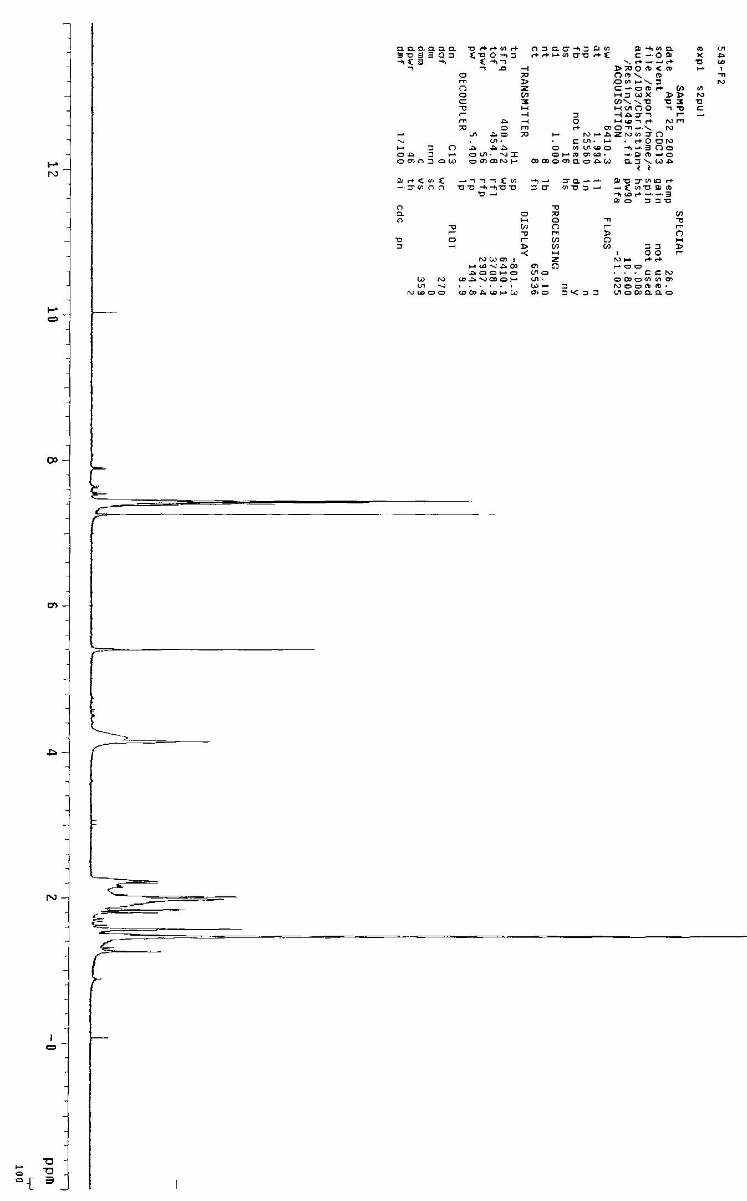
6

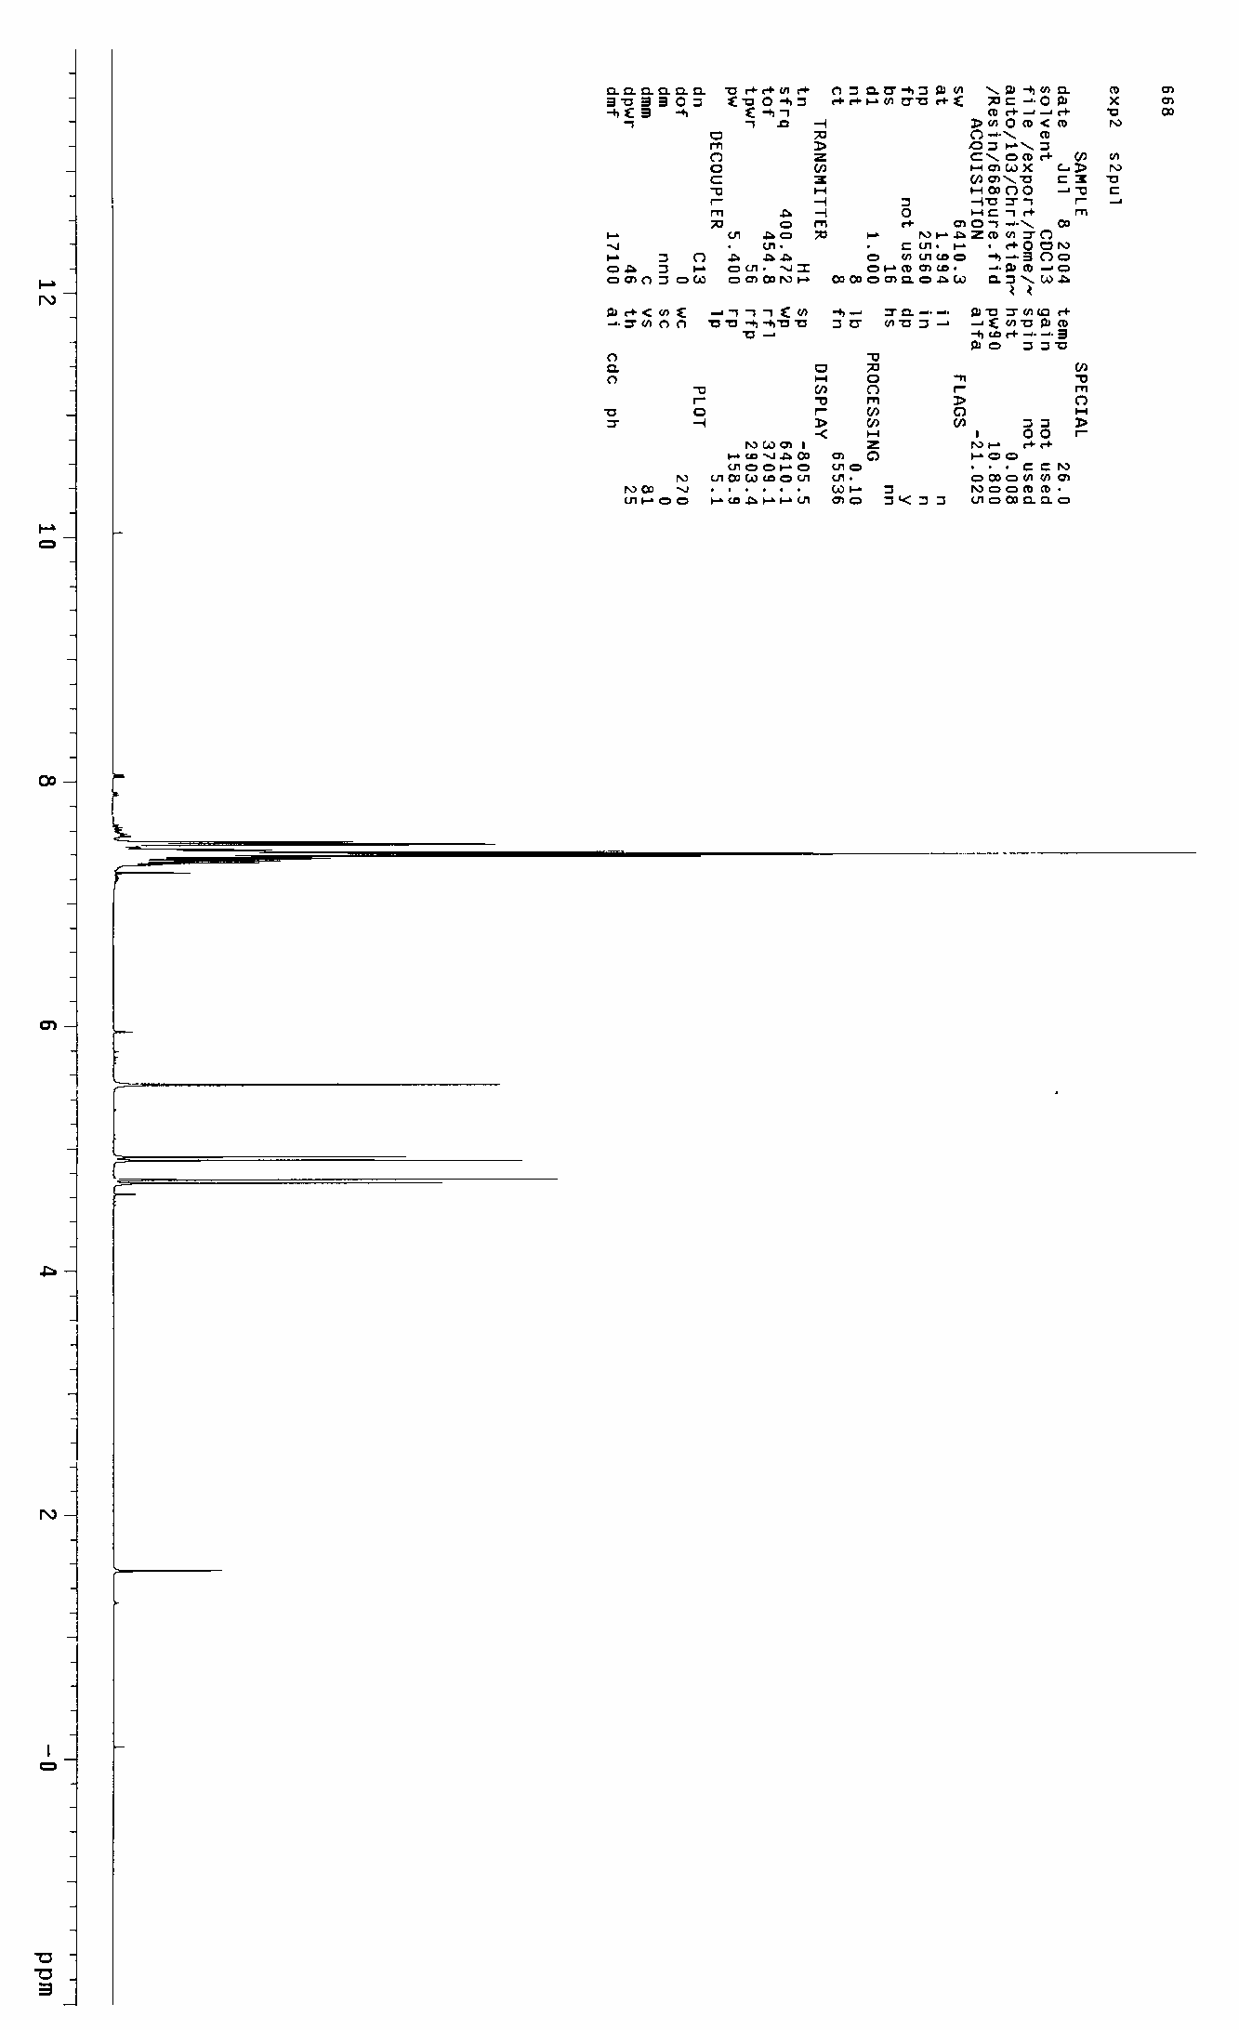
8

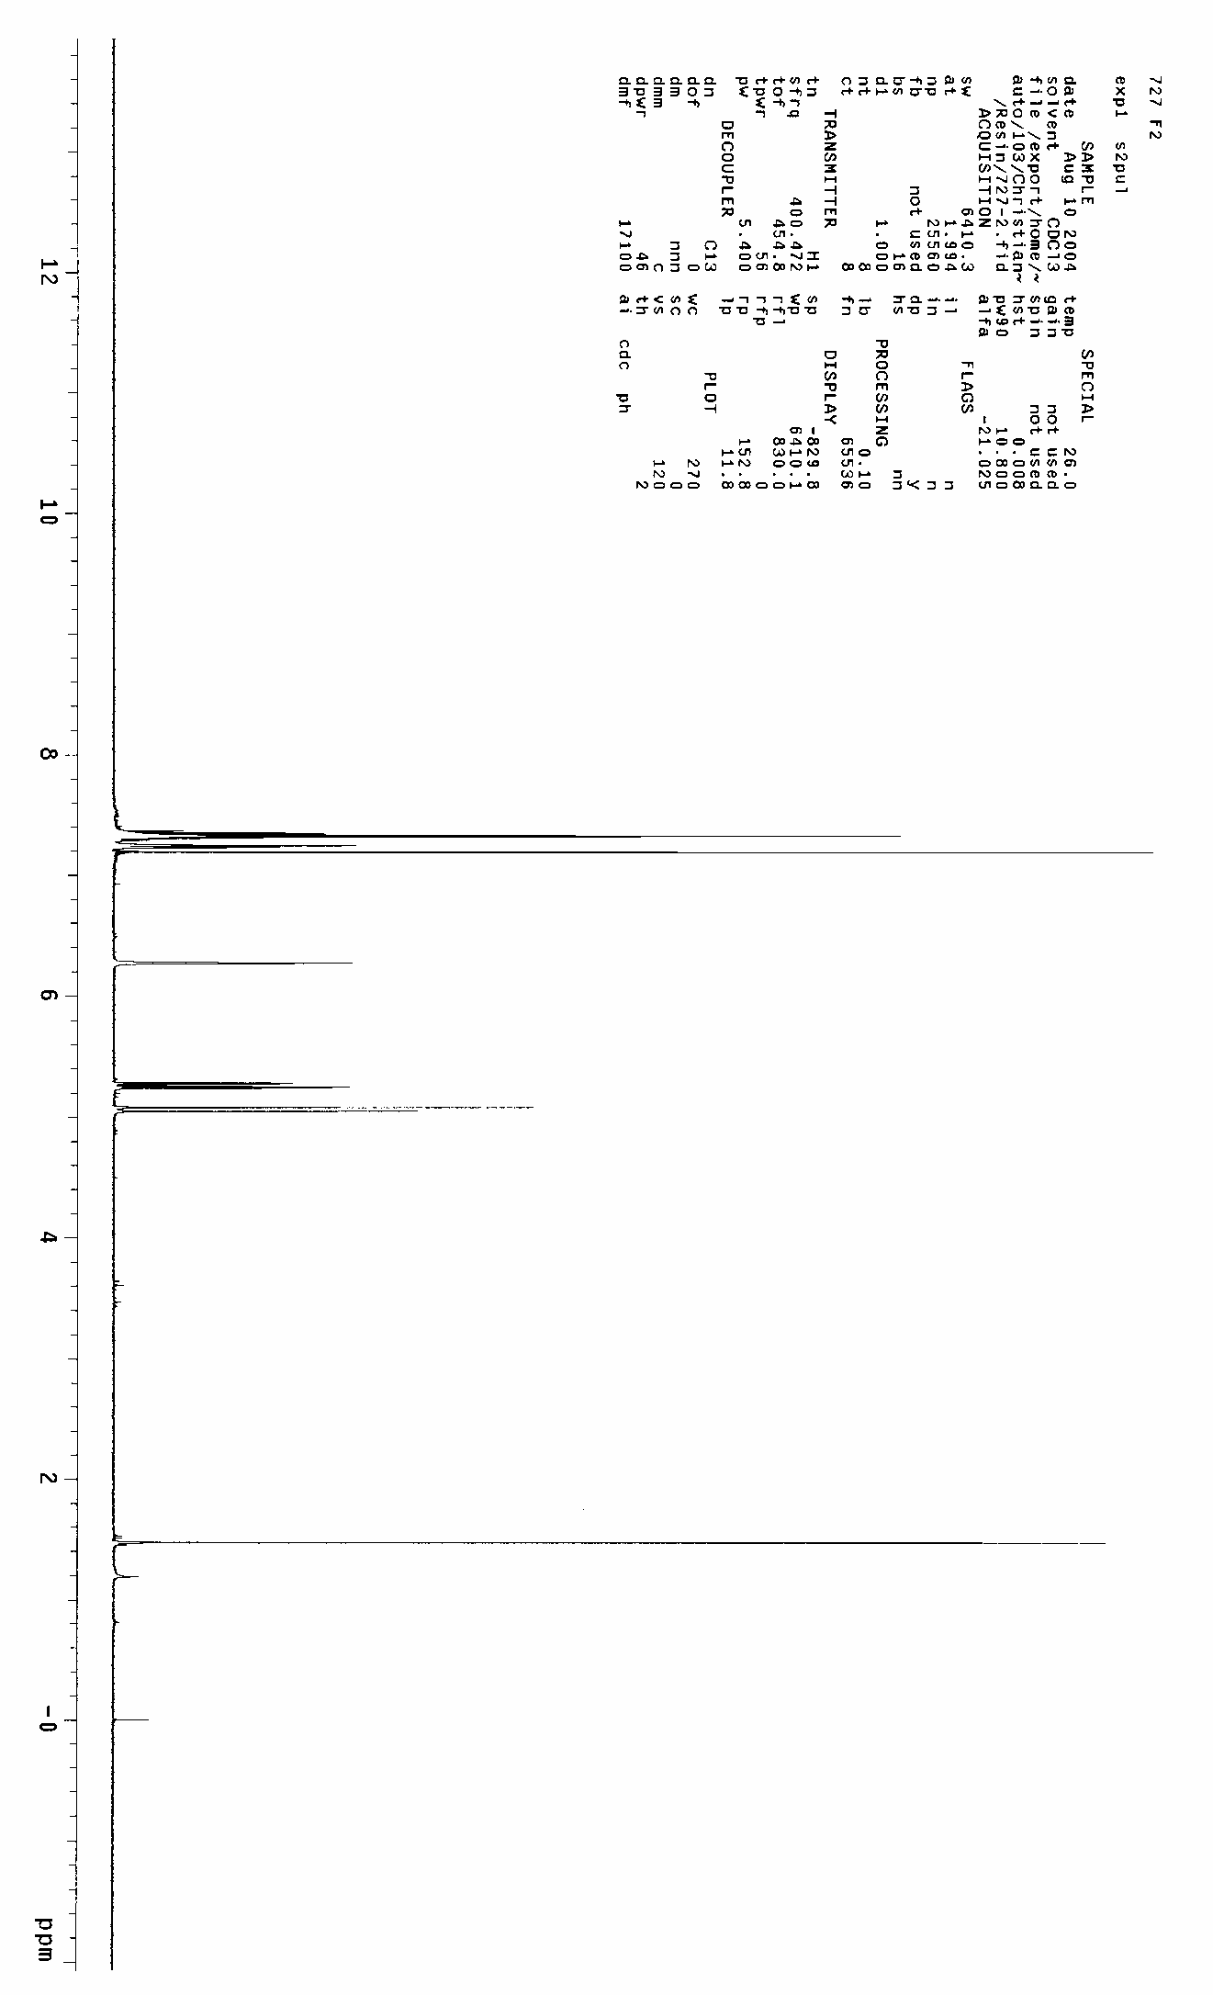
10

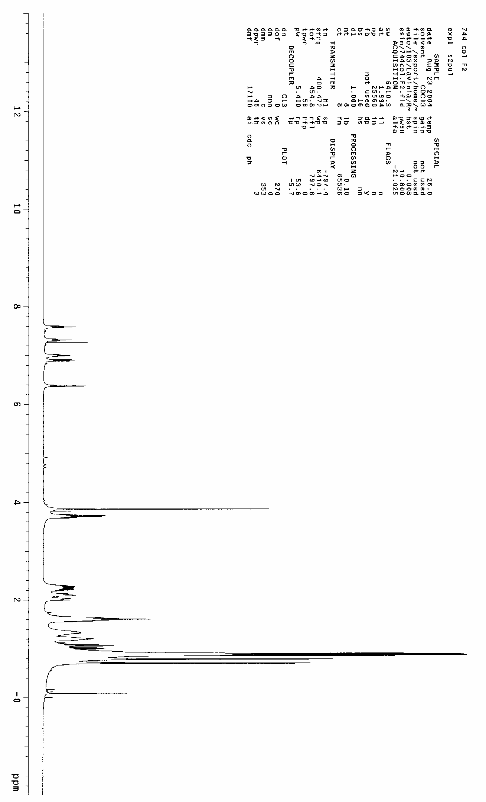
12

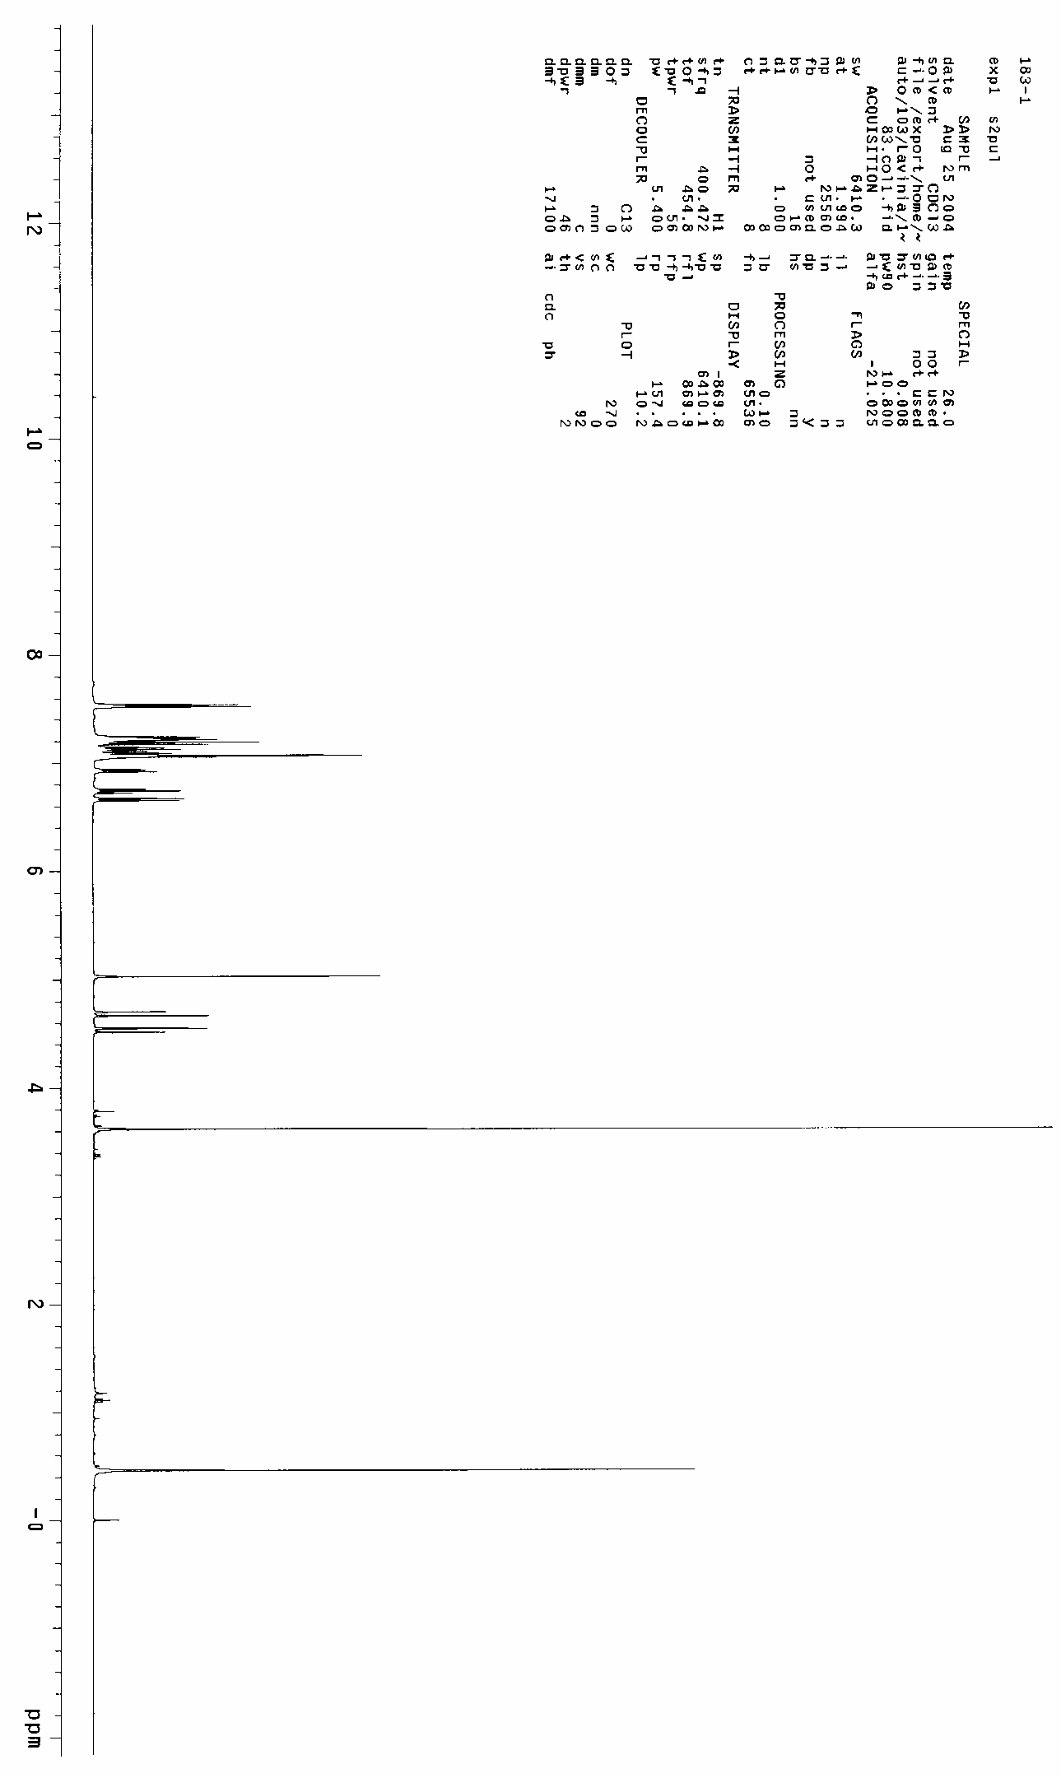
13

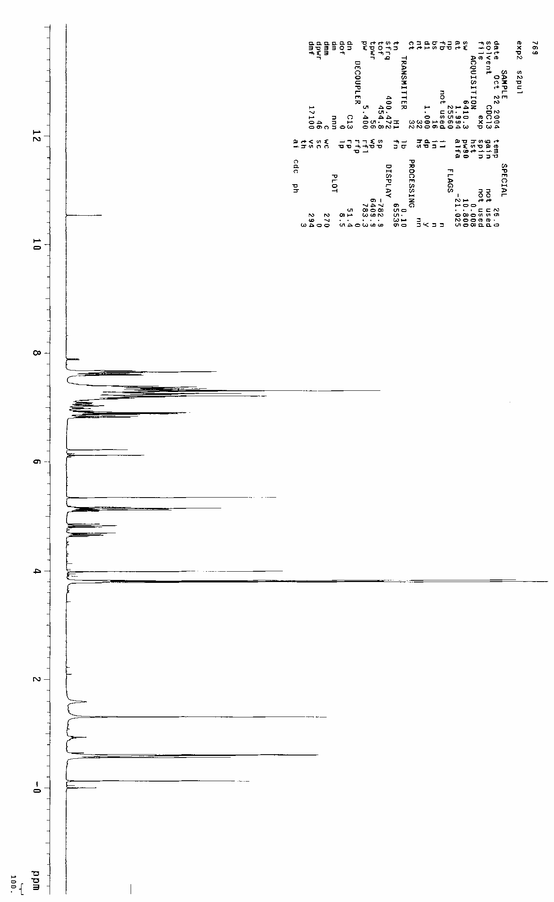
14

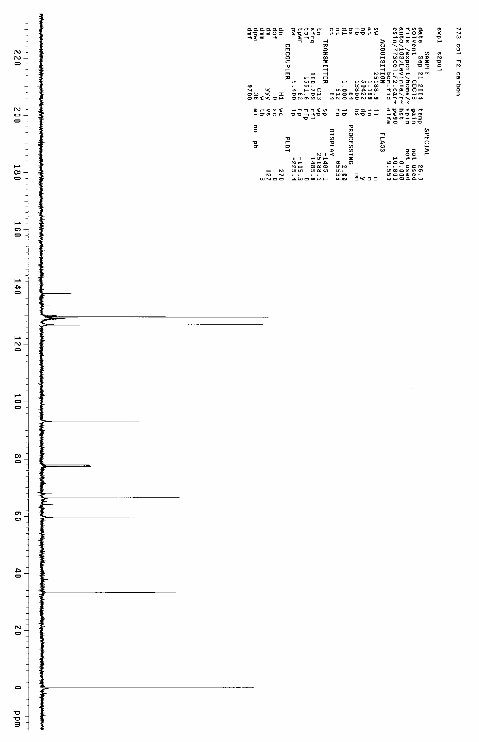
16

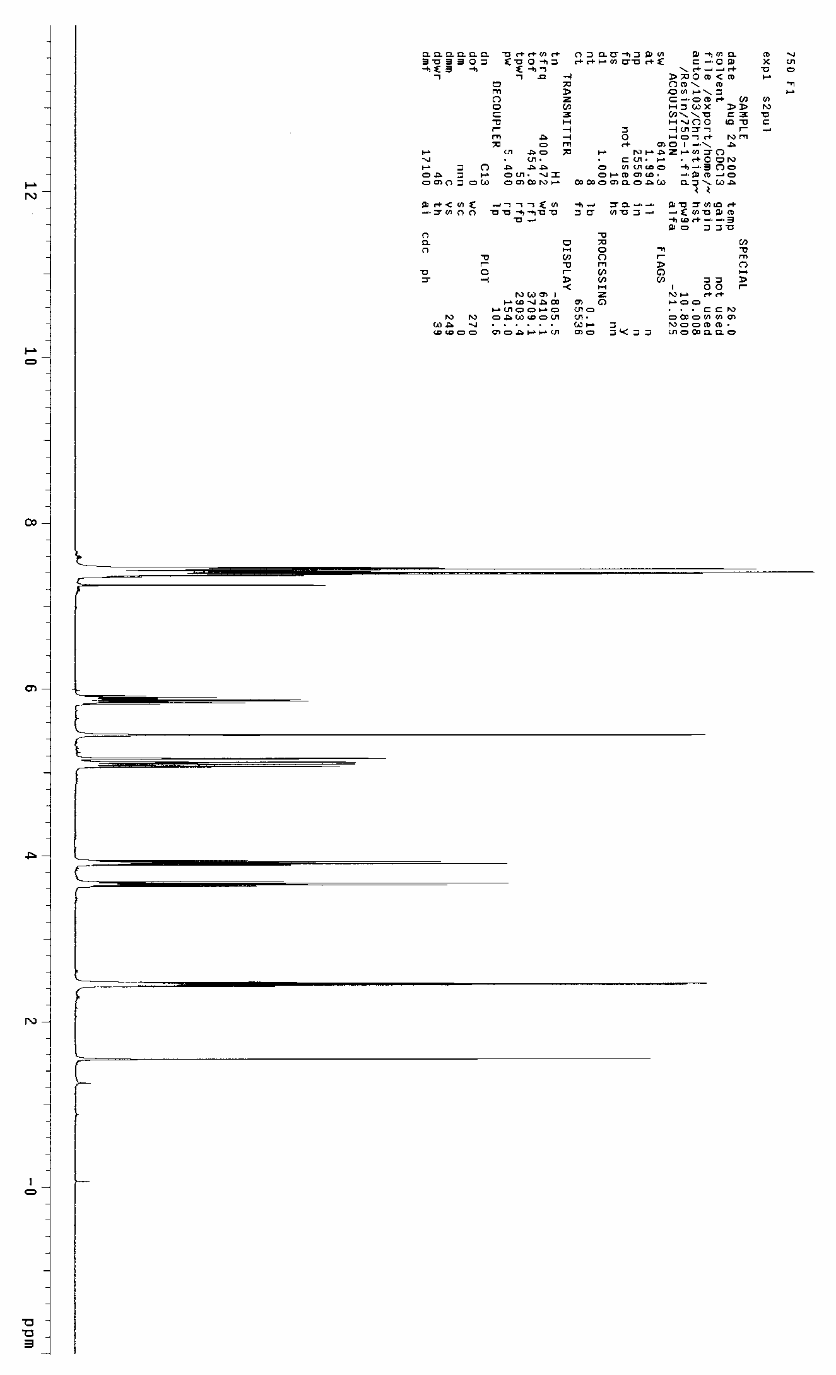
25a

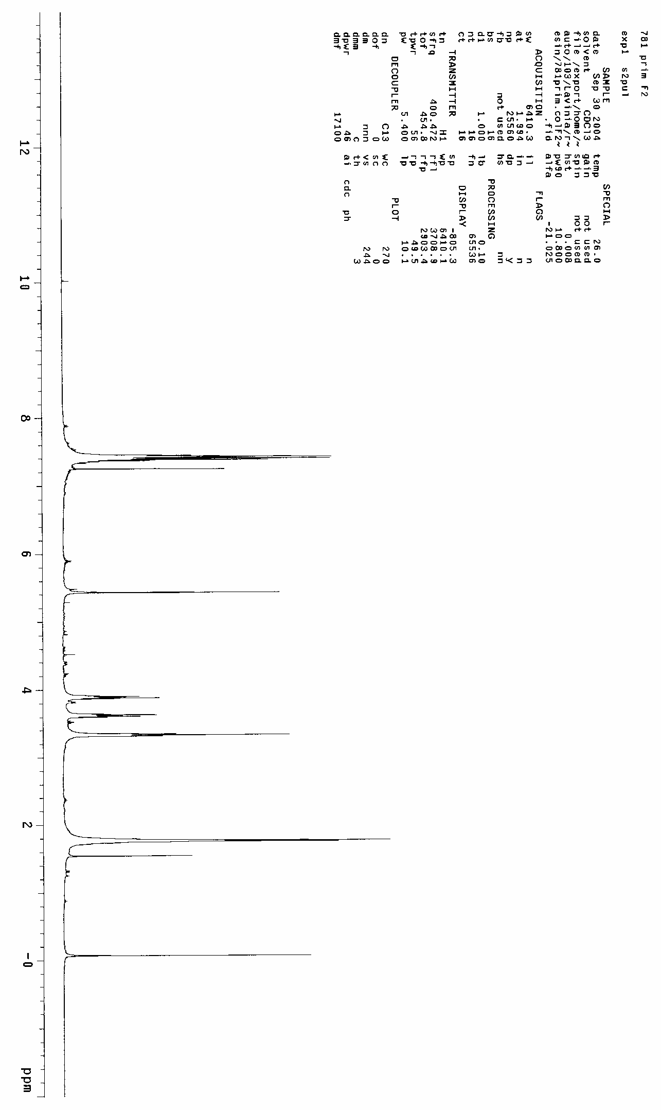
26a

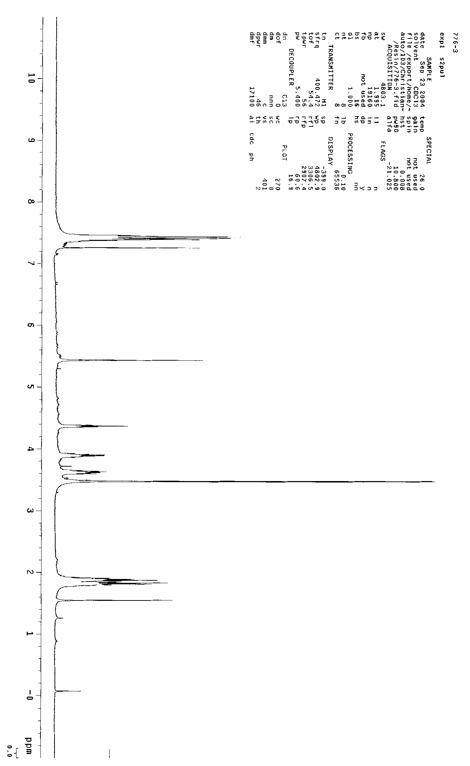
26b

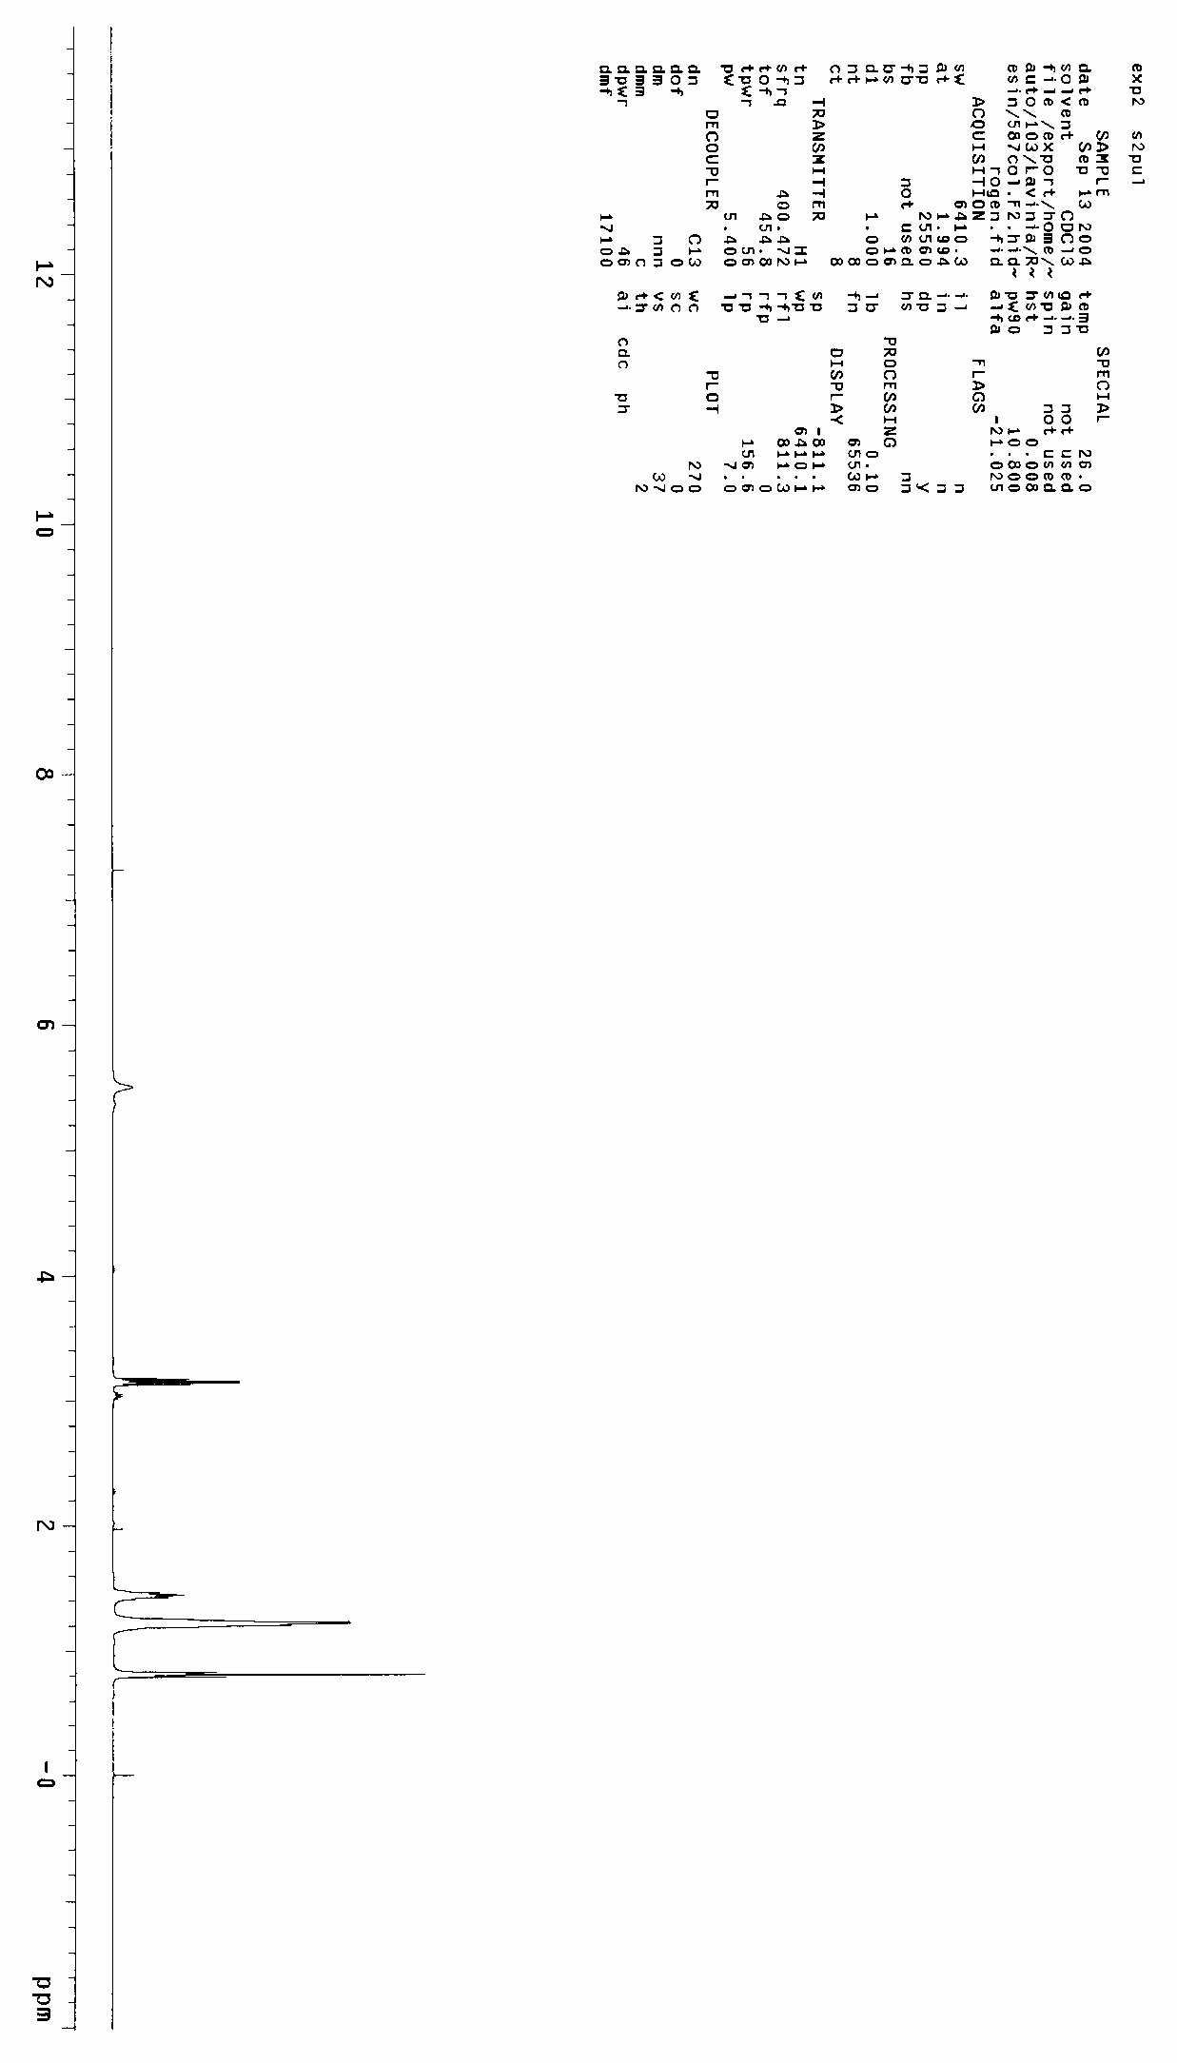
30

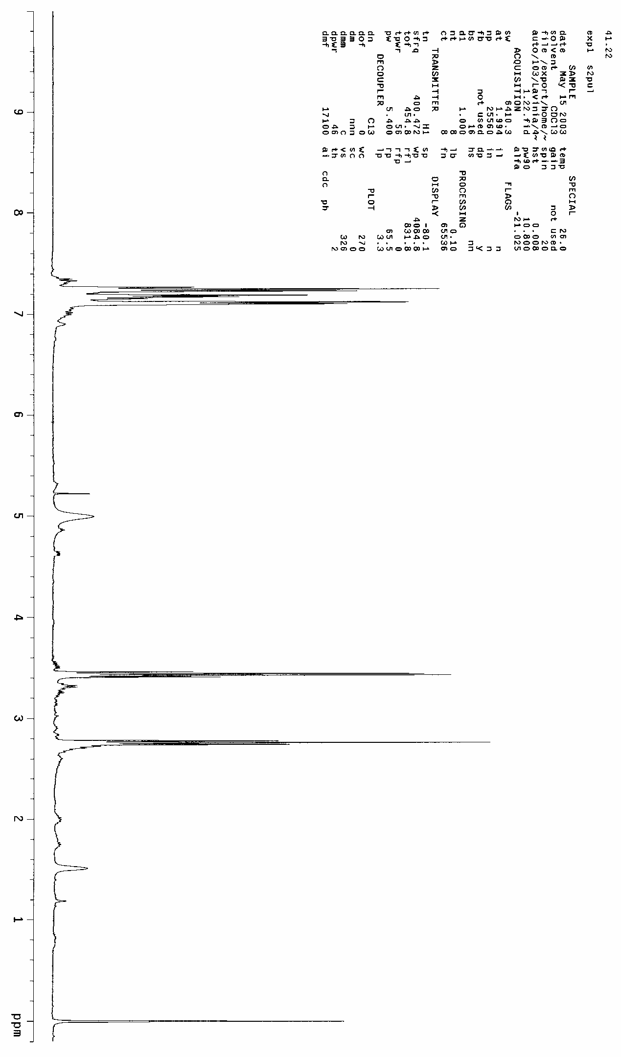
32

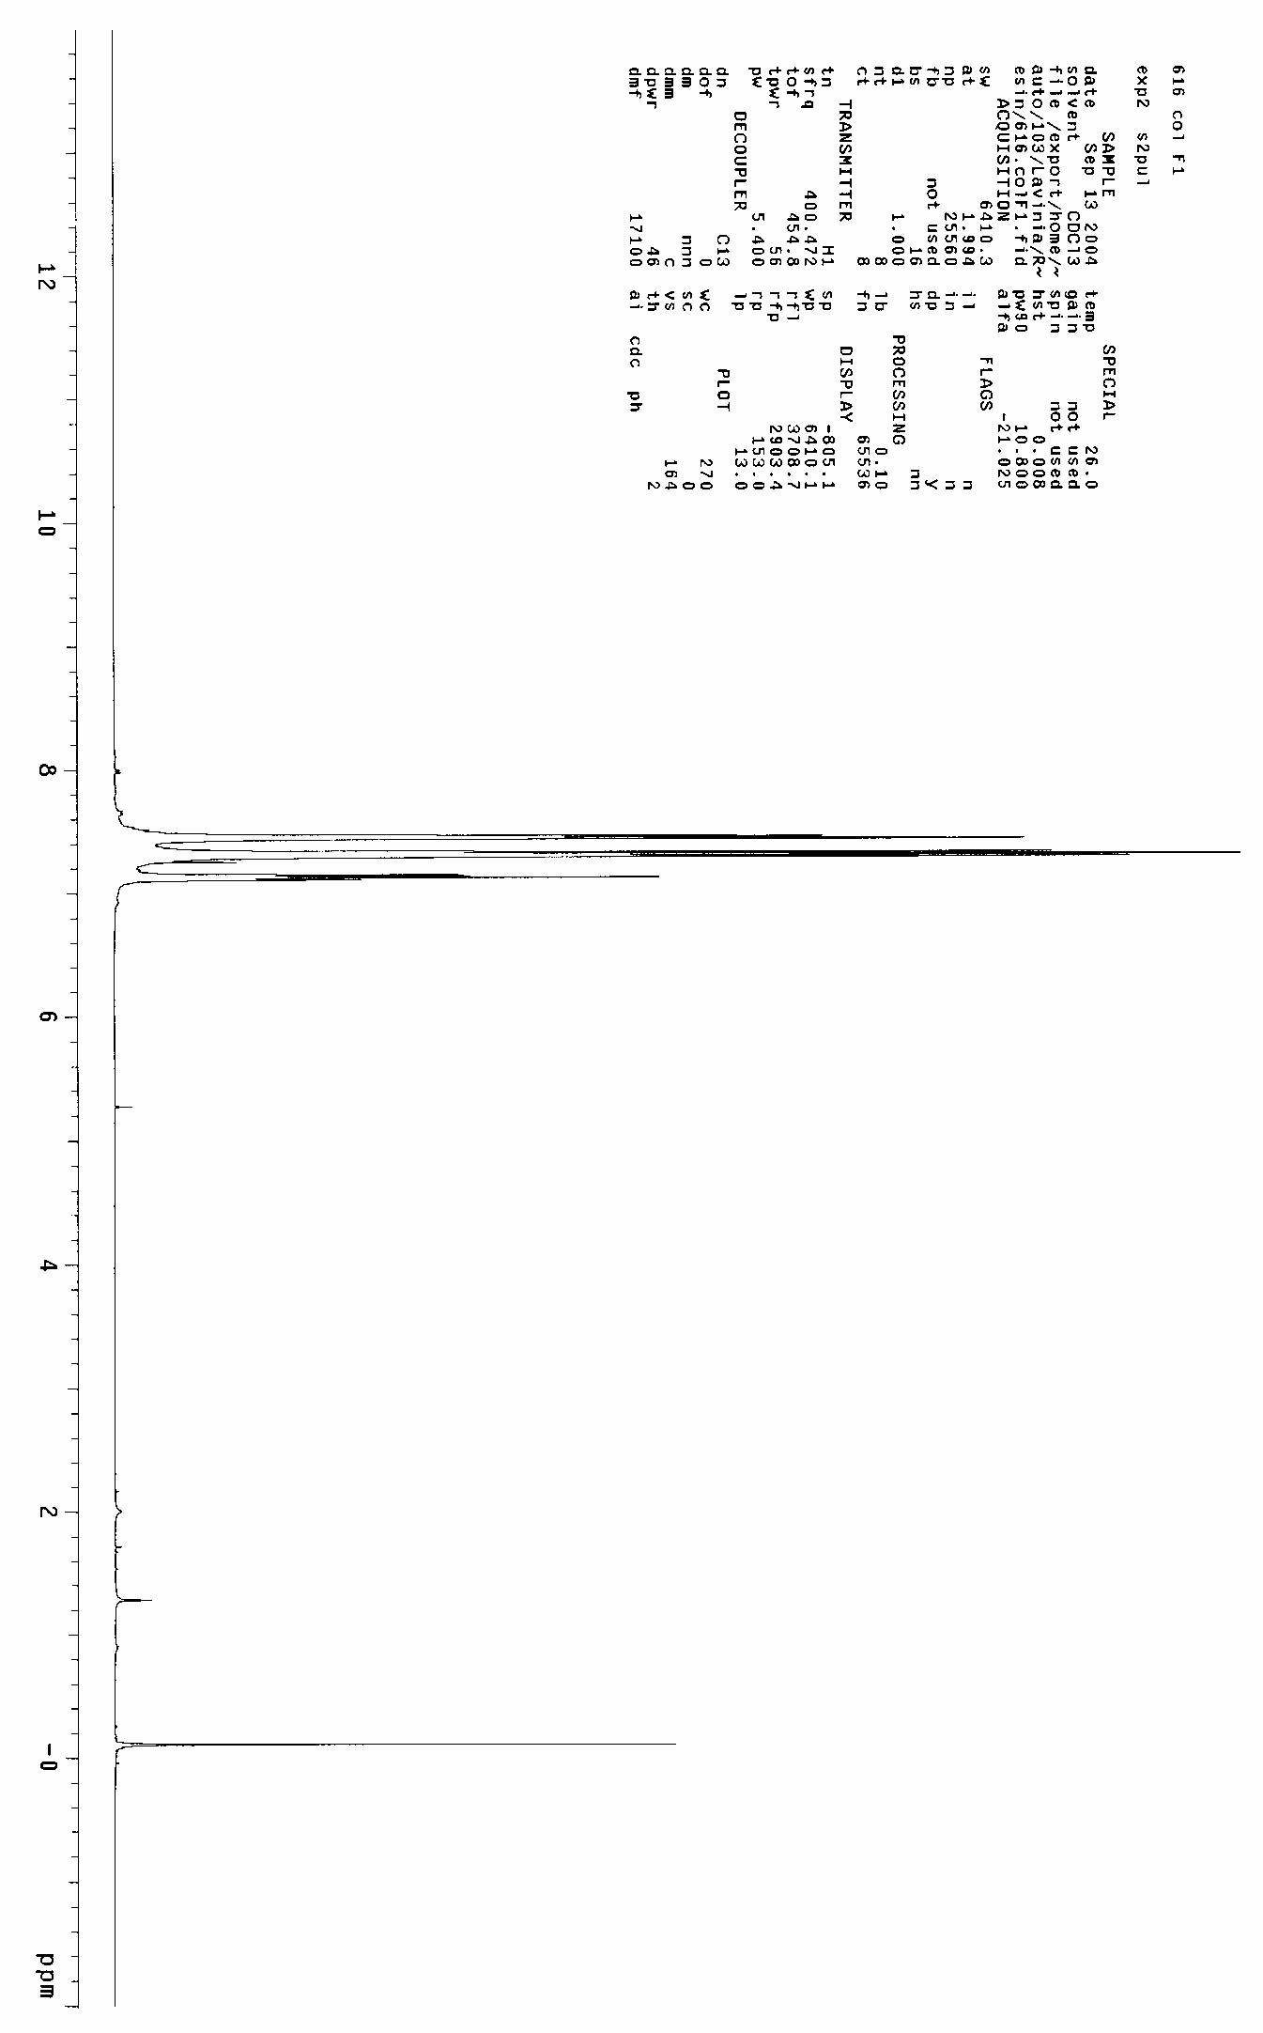
34

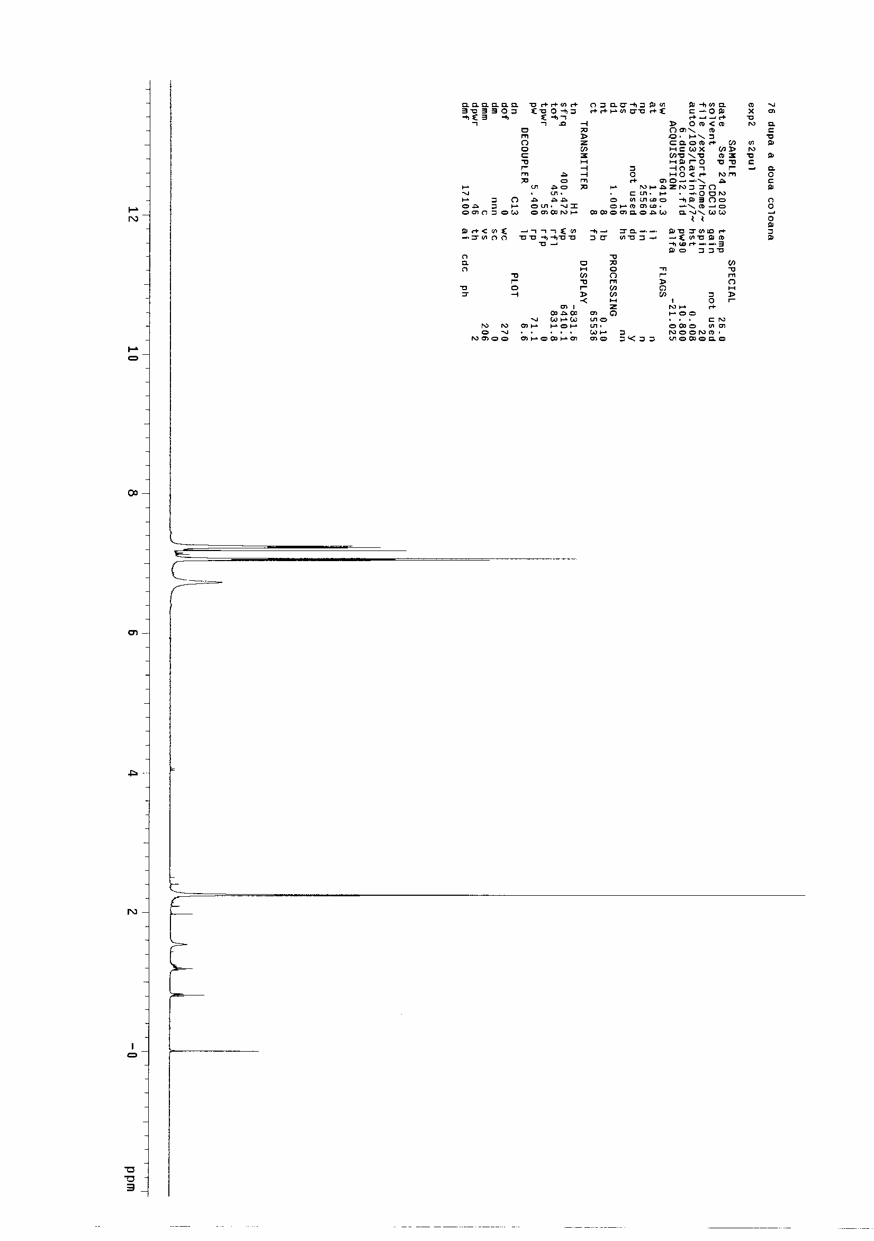
36

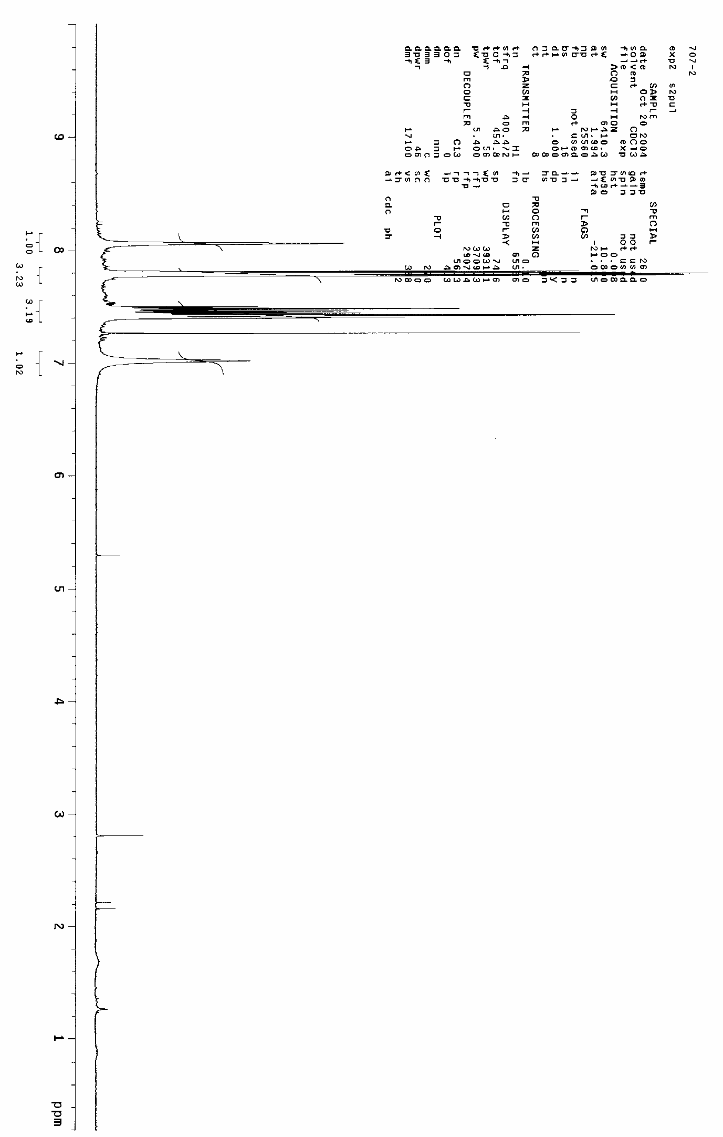
38

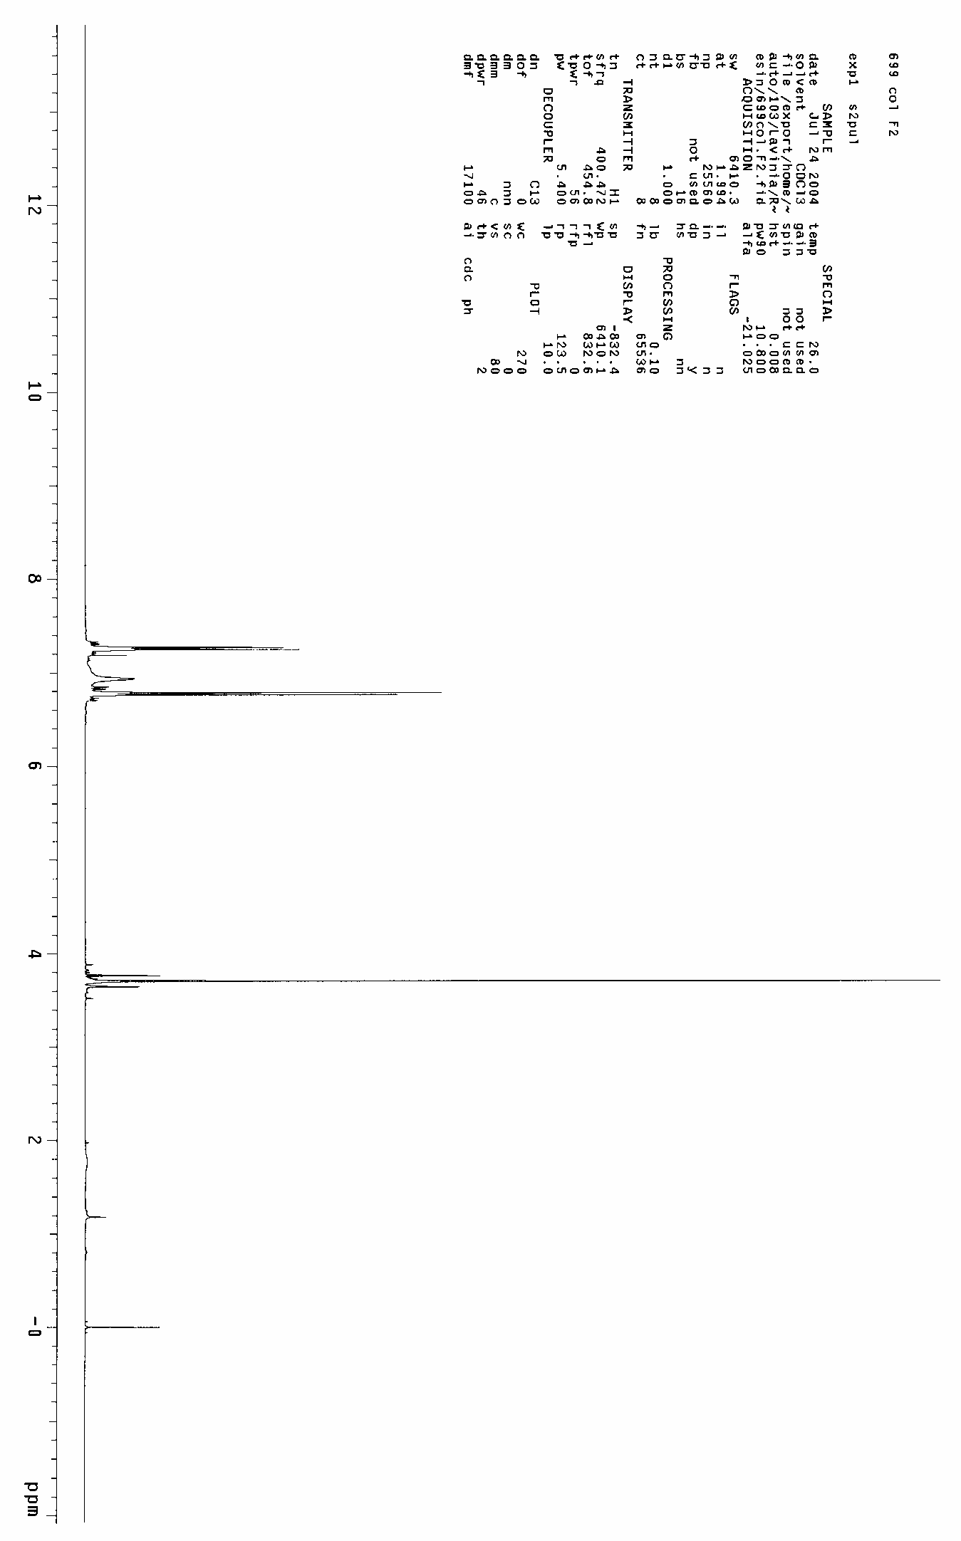
40

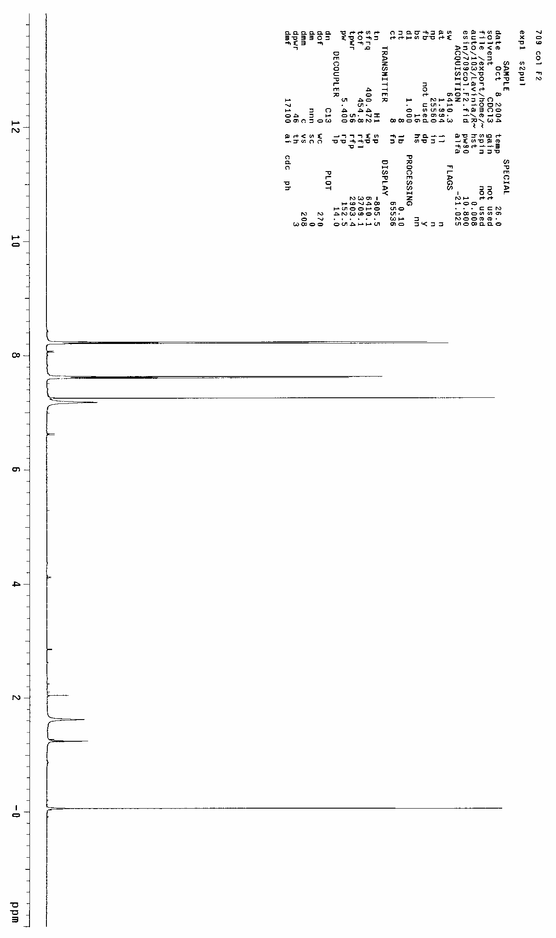
42

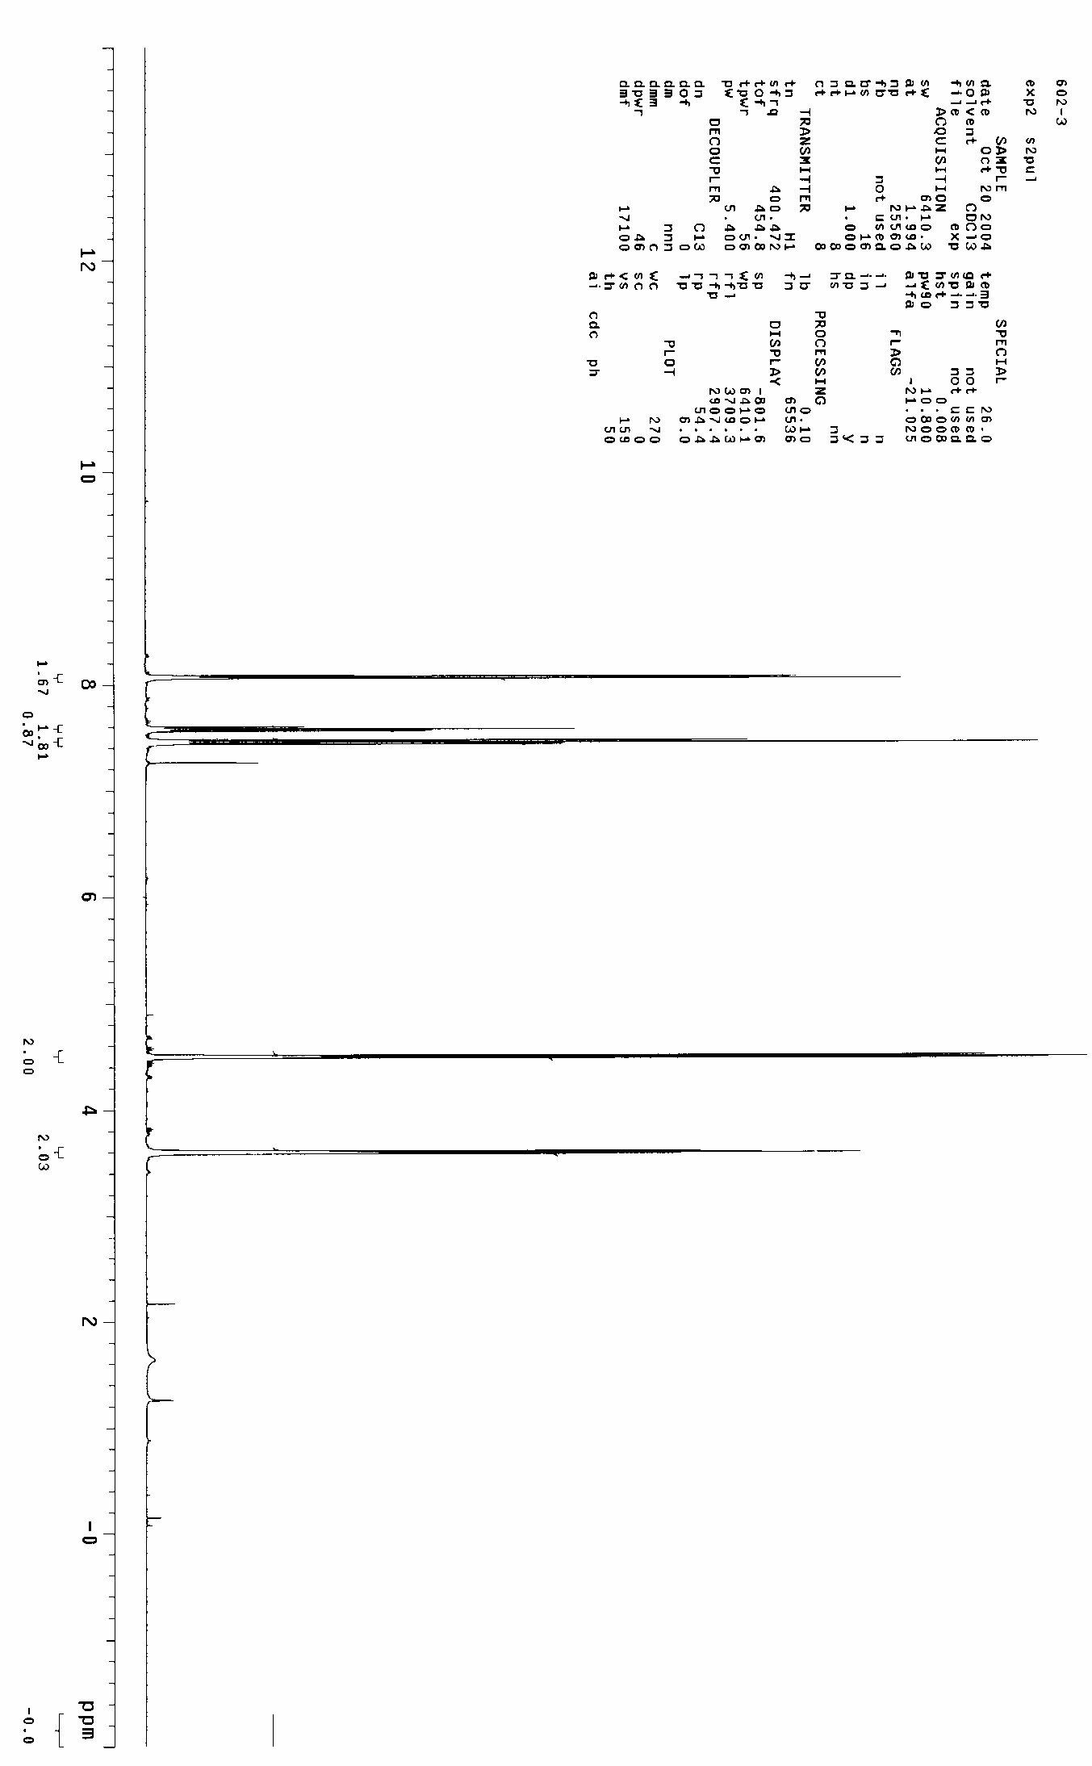
44

